Masibambisane Day care & ECD Centre in ELDORADO PARK - Wish List -

315 CHILDREN

Stationary for school / A4 paper / Dictionaries | Large Food Processor for meal preparation / Baking trays | Hygiene items, (All types) Washing Pegs
Digital Internet Cable with Installation | Garden tools | Toilet Rolls
PA System / Digital Camera | Curtaining for ECD center & big hall. | Repair/replacement of some ceiling boards and cornices
Kitchen aprons / Mop Caps - Disposable | Educational tour to Durban for 60 primary & high school children. | Electrical repairs that require an electrician to complete
Air Conditioners/Fans for the hall and classrooms for summer x 5 | Psycho-Social Camp for 60 primary & high school children. | Repair of roof wooden beams and fascia boards
Astroturf in the primary school children play area to replace the sand and mud | Heaters for hall and classrooms for winter | Shade cloth for 4 car structure
Arts and craft material (All types) | Cleaning materials and tools (All types) | Groceries for Food Parcels for 150 families monthly
Sports team uniforms -Netball
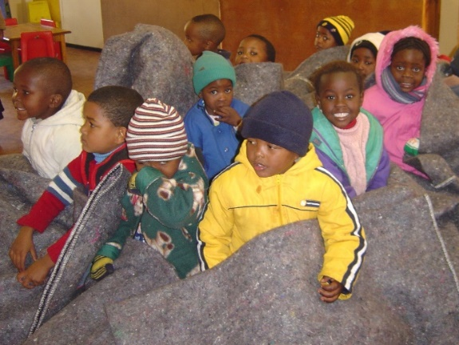
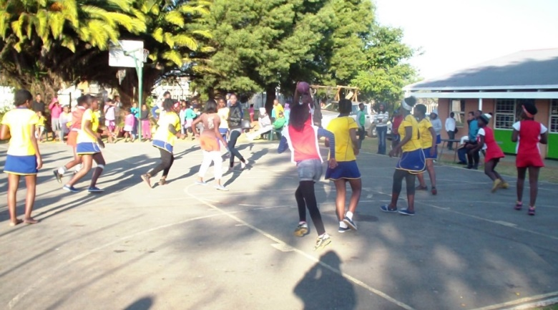

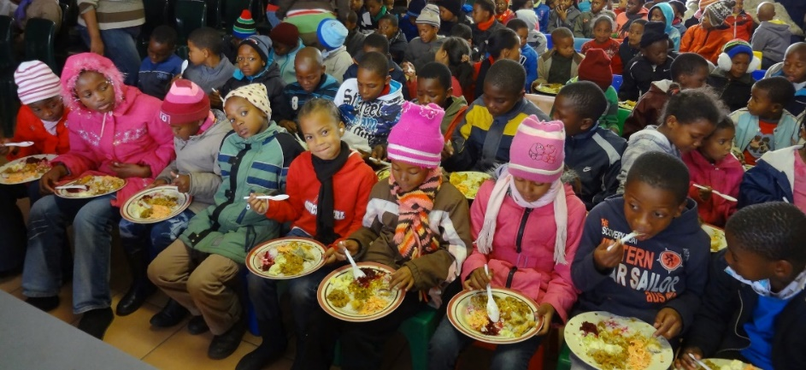

OTHANDWENI RESIDENTIAL HOME IN SOWETO – WISH LIST – 90 CHILDREN

NURSERY (30 CHILDREN AGES 0-4 YEARS)

Disposable nappies (size 2- 5) | Nan Pelagon baby formula (1 & 2)
Milton (baby bottle sterilizer) | Wet Wipes
Nespray | Teats (standard size)
Washing Powder
Nestum | MEDICAL
Nido | Panado syrup
Aqueous cream | Rehydrating solution
Camphor Cream | Allergex Chloramax eye ointment
Toilet papers | Sweet oil
Snacks | Amoxyl syrup
Twin saver pop up tissues | Baby Multi vitamins
Babies and toddlers clothes | Benzac ointment
Toys | Tegaderm dressing
TOILETRIES | LAUNDRY
Dettol | Washing Powder
Aqueous cream | Sunlight bar soap
Camphor Cream | Stay soft
Toilet papers
Twin saver pop up tissue

COTTAGES (60 CHILDREN AGES 5-18 YEARS)
TOILETRIES
Girls panty liners
Bath soap
Roll-On Deodorant
Toothpaste
Tooth brushes
Toilet paper
Face Cloths
Hair food & cream relaxer’s
Hair dryer x 4
New Underwear and clothing

MAINTENANCE

Drilling machine and bits | Roofing screws
Wood planner for wood | New gutters ( for all cottages, admin & nursery )
Refuse bags | Wood paints
Energy saver- globes | Fascia boards (for all cottages, admin & nursery )
Window handles | Steel door for container
4 x Door frames | Roof paint ( Midnight Blue)
Electric sander for wood | Irrigation system for the garden
Jigsaw | Vegetable Seeds
38 x 114 mm wood beams for roofing (6 m x 3)

STATIONERY

Counter books 192 pages ( faint & margin) | Plastic pocket file (120)
Pritt glue stick | Scissors
Blue, red & black pens | Sellotapes
Correction pen | Highlighters
Scientific calculators | Typex papers
Erasers | Flip files (yellow)
Facial tissues | Maths set
Zulu – English dictionary | Atlas books
Covers and plastic covers

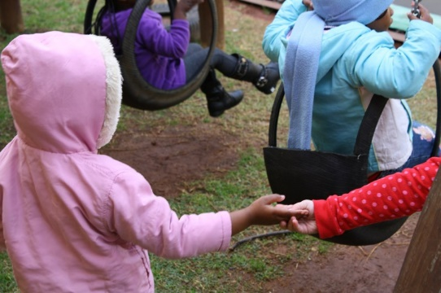
ARTS, SPORTS AND CULTURE

Traditional dance attire
Choir attire
Gum boots & Overalls for gum boots dance
Registration fee for Presidential Awards children
Karate attire
Tekkies for teenage children (Boys and girls)

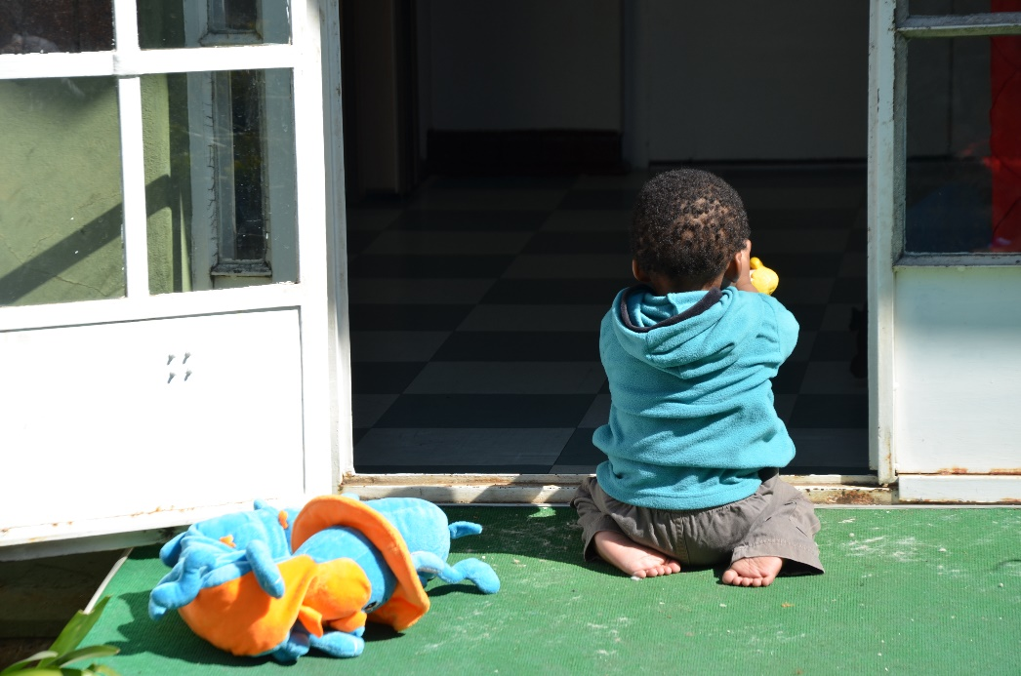

PRINCESS ALICE ADOPTION HOME IN WESTCLIFF – WISH LIST – 30 BABIES

MEDICAL | TOILETRIES | BABY CARE PRODUCTS | FOOD ITEMS
- Dis-Chem Vouchers (for OTC medicines & toiletries)  - Multi-vitamin syrups  - Prospan/Flemeze Cough  - Nystacid ointment  - Panado/Calpol Syrup  - Allergex Syrup  - Biocort/Mylocort  - Rehydrate  - Liquid Paraffin  - Band-Aid/Plasters  - Sudocreme | - Tissues  - Dis-Chem Voucher (for toiletries and OTC medicines)  - Baby Soap  - Wet Wipes  - Bath wash/ Top to Toe  - Vaseline | - NAPPIES: - sizes 2, 3 & 4  - Bath Towels  - Silicone bottle teats – standard sizes  - Standard baby bottles  - Latex gloves (M/L)  - Disposable Aprons  - Sippy Cups for Older Children  - Feeding Spoons | - Milk Formula:  - Nan Pelargon 1/ Nan 1  - Nan Pelargon 2 / Nan 2  - Nan 3 /Lactogen 3  - Pick ‘n Pay / Checkers gift vouchers  - Fruit & Vegetable Purity  - Variety of Fresh Fruit  - Nestum/Cerelac cereal  - Snacks for toddlers e.g. Mini Cheddars/ Biscuits/Flings/Cheese Curls/Popcorn
HOUSEHOLD | URGENT ONCE-OFF ITEMS / SERVICES |  | URGENT ONCE-OFF ITEMS / SERVICES CONTINUED
- Full Cream Long Life Milk  - Regular/Rooibos Tea  - Coffee  - Sugar  - Handy Andy  - Paper Hand Towels (available from Westpack, Dis-Chem, etc.)  - Refuse bags  - Washing Powder  - Fabric Softener  - Dish Washing Liquid  - Pine Gel  - Anti-bacterial surface cleaner  - Toilet Paper | - Waste Bins (attachable to walls) for nursery basins  - Mesh wire shelving for Nursery and pantry  - Educational toys/materials for toddlers and babies.  - High Chairs  - Pamper items to make up Christmas Hampers for 25 Caregivers & Domestic staff  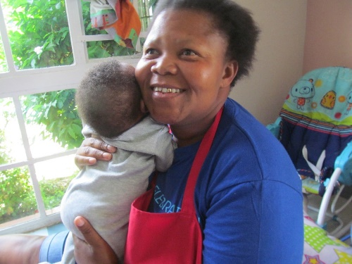  - Pamper items to make up Christmas hampers for 15 Grannies |  | - Christmas clothes for children  - Christmas presents for children aged Newborn to 3 Years old  - Waterproof cot sheets/ mattresses  - Medium size kitchen pots with lids  - Battery Operated Doorbell

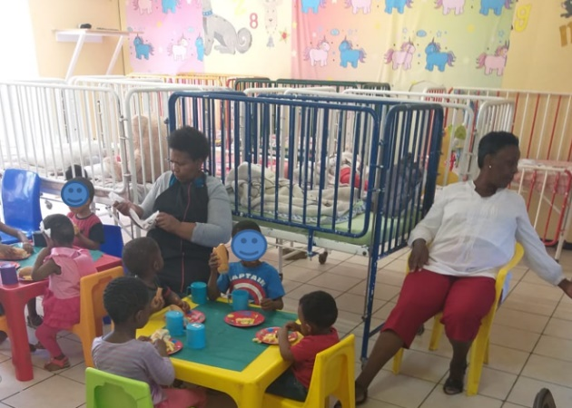
Head OFFICE – WISH LIST

ADMINISTRATION
Aluminium Fixed Asset Tag Machine
Barcode label machine and mobile printer
Typex A4 Paper
Office chairs
Small office desks
Cleaning products (All types)
Laptops / Computers
Transportation bakkie (1 ton)
Small vehicles for social workers

CHILD AND FAMILY DEPARTMENT & FOSTERCARE DEPARTMENT– WISH LIST

Baby Milk Formula | 0 – 6 months ; 6 – 12 months; 12 months+
Diapers | All Sizes
Wet Wipes | Non Deoderized
Vaseline
Bum cream
Baby bottles
Groceries:  Mealie meal  Cake Flour  Instant Oats  Samp  Rice / Pasta / Spaghetti  Soya Mince  Two minute Noodles  Fish Oil  Tin Foods (All types)  Rooi Bos Tea / Tea & Coffee  Sugar (prefer brown)  Bath Soap  Toothpaste  Automatic Washing Powder  Sta - Soft | As much as you can for food parcels for places of safety families.  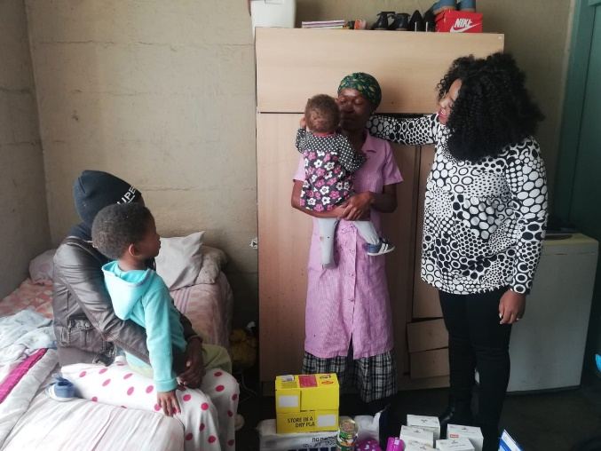
Dry Rack | To dry washing at the office
Clothes  New Under wear,  Shoes | All sizes for new born to adults.

